CYB 310 5-1 Lab Worksheet

Andree Salvo
Southern New Hampshire University
CYB 310-13007
5-1 Lab Worksheet
Instructor: Raschid Muller
9/2/2025

Lab: Closing Ports and Unnecessary Services
Prompt | Response
In the lab section, "Connecting to the Open Ports and Services Using Telnet and FTP," Step 13, complete the steps, type your name after the command prompt, and take a screenshot of the output. | 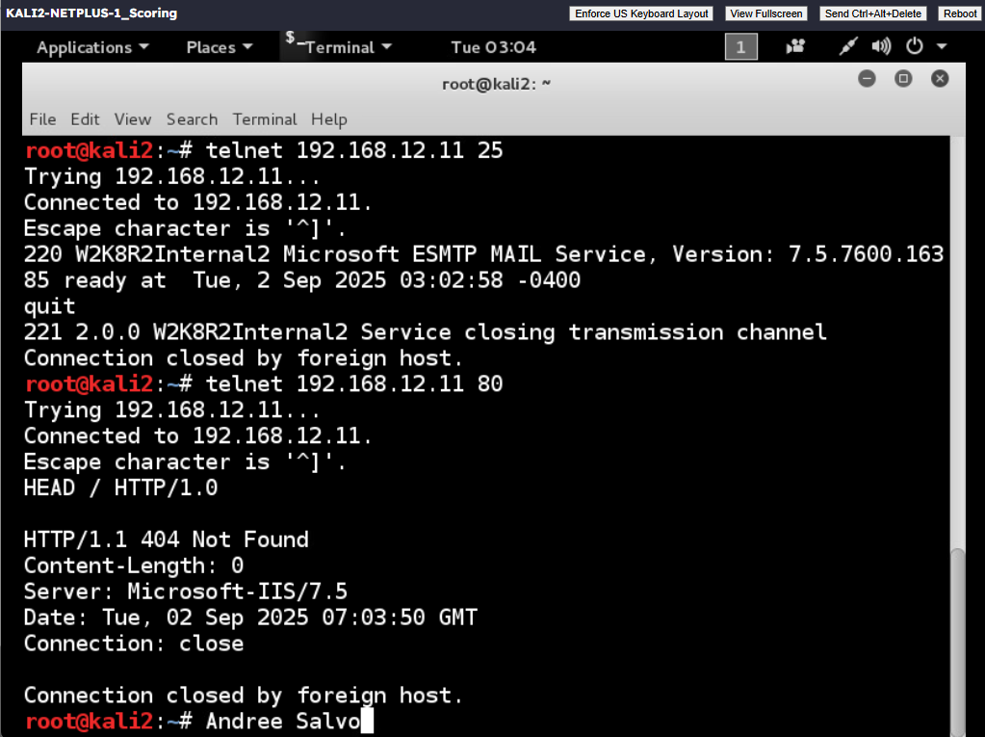
In the lab section, "Closing Unnecessary Ports and Services," Step 26, type your name after the command prompt and take a screenshot of the output of the scan of port 80 (www) on the Windows machine after closing HTTP services. | 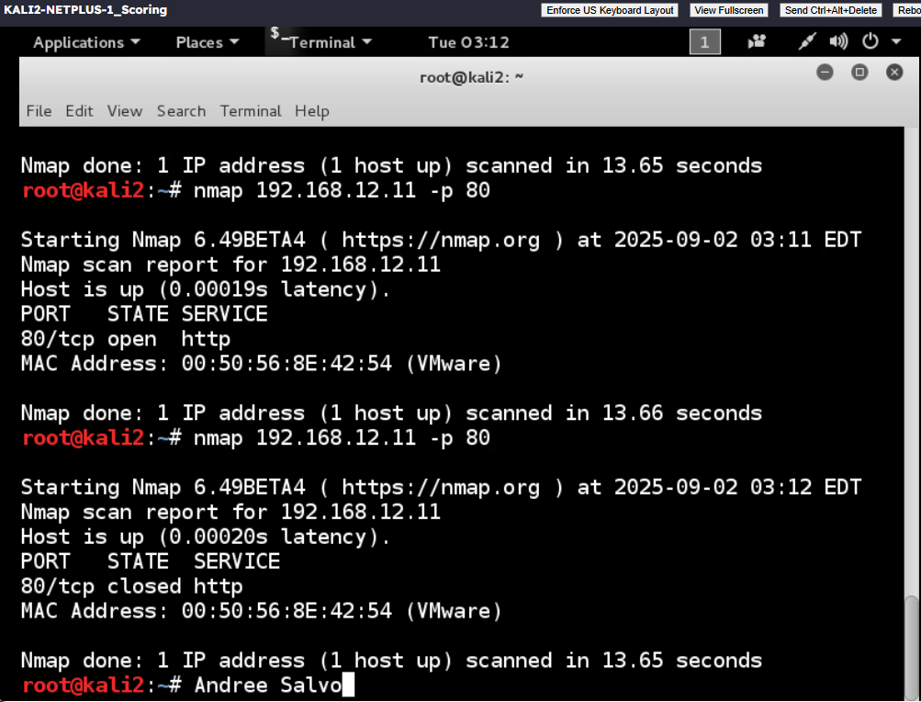
Closing unwanted ports and communication mediums is essential to network hardening. Why is this essential and how does it help with network defense? | When it comes to closing unused ports and communication paths, it helps reduce the attack surface, making it much harder for a threat actor to exploit a vulnerability or even infiltrate the network.
Using an adversarial mindset, how can you test to make sure only needed ports are open? What tools would you use? | When I’m using an adversarial mindset, the first thing I would do is to test any open ports by scanning the network with tools like Nmap or Wireshark to confirm that only necessary ports are accessible.

